Patterns of niche and range shifts in European breeding birds under climate change- Research plan

Research questions;

* Are European birds tracking climate change or adapting to new climatic conditions within their current range?

*Hypothesis:* As other studies, we expect incomplete climate change tracking with much variation between species (differential capacity for range shift and climate tolerance).

Important Decisions/Questions;

Species data;

* Converted EBBA records to the same CRS, albers equal area projection for europe (ESRI:102013). Using an equal area projection that matches that used for environmental data.
* Clipped out data from Eastern Europe + Canaries where EBBA2 methods state comparison is not appropriate. Would be better to use cells shown in EBBA2 Methods chapter fig. 9. But no access to these cell ID’s currently.
* Resolve taxonomy for some species that changed between EBBA versions, based on EBBA2 methods in comparisons;
  + Change *Acanthis hornemanni* to *A. flammea* in EBBA1.
  + Removed all species from EBBA methods Table 6 that have change map=NO or YES*, as not directly comparable from EBBA1 data.
  + Then removed all remaining species that had 0-4 records in one EBBA (70 from EBBA1 and 160 from EBBA2), though likely some of these are equivalent, but have changed genus or species name.
* Removed all species recorded as pelagic specialists in Wilman et al. EltonTraits database (<https://esajournals.onlinelibrary.wiley.com/doi/abs/10.1890/13-1917.1>).
* Removed species with <20 occurrences in one or both of the EBBAs.
* Removed species occurring in >90% retained EBBA cells in EBBA2 database.
* Remove species with only peripheral range from IUCN polygons within EBBA sampling area.
  + - If <70% of the distribution is within EBBA sampling region, then removed- following (Ref: Ralston *et al.*, 2017).
    - Very low overlap with IUCN polygons- many species are pan eur-asian and/or American but also the IUCN polygons seem quite conservative (instances of species with zero overlap despite breeding records in Europe in the EBBA data).

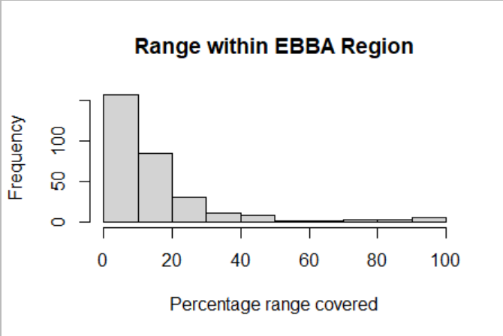

* + - Try different global datasource (e.g., GBIF/eBird), or select low threshold maybe 5%, just to remove the most peripheral distributions?

Environment data;

* Took from IBB- CHELSA climate data from 1981-1990 and 1999-2018. Adjusted code from env_info.Rmd (GitHub). Reprojected CHELSA data to 50km resolution and albers equal area projection for Europe.
* Calculated bioclim values from these for first explorations, summarizing years 1981-90 for EBBA1 and 2009-2018 for EBBA2 (10 year average for each atlas, bias to pre-survey to account more for time lags, 20 year gap for climate change effects). Can be adjusted.
* Clipped out data from Eastern Europe + Canaries where EBBA2 methods state comparison is not appropriate. Would be better to use cells shown in EBBA2 Methods chapter fig. 9. But no access to these cell ID’s currently.
* Experimenting with adding landcover data to complement climatic data- Progress;
  + LUH2- Downloaded annual layers 1980-2015, download modelled data after this. Katrin suggested that differences in scenarios will be quite small for 2016-18. Provisionally took the middle of each EBBA survey period (1985 and 2015) as a reference year and included all 14 LUH2 class rasters from these years as environmental predictors with bioclimatic data. Take average land cover across the same years as the Bioclimatic layers. Unclear how meaningful averaging across years would be. Analytically simple option as data sourced as rasters with coverage values, so only need simple reprojection (but maybe tweaking with some linear rescaling to roughly match the ranges of bioclim variables could also be warranted).
  + Maybe remove or simplify landcover representation: without landcover PCA 1 and 2 cover approx. 70% variation, with all LUH2 layers added this is 50.5%. Also running with the 14 LUH2 layers slows down processing considerably. Run PCA with LUH2 data only.
  + Running with just Bioclim variables for time being. Might be more appropriate to keep simple with a climate focus, rather than complicating with Land-use and other environmental changes?
* Calculated overall climate change represented in between the EBBA1 and 2 time periods (e.g., for baseline comparisons and commentary etc.). Achieved by running ecospat analyses using a complete sample of the environmental cells instead of species presences as species input. Results: Schoener’s D: 0.951, stability: 0.998, PCA centroid shift was also small (0.289 on the PCA scale) Appears very little climate change between the two periods currently represented, may need to rethink enviro data to ensure a clear signal of climate change is present.

Niche analyses;

* Analyses in ecospat
* Working analysis foreach loop
* Trialling buffers of 300-700km (going up by 100km steps), so far only minor differences in outputs observed (rough sensitivity analysis/graphing completed).
* Using background samples cover all environmental cells in buffers. I think the best and simplest rule to be consistent (rules of x*sample size exceed number of cells in buffer regions for more common species).
* Niche similarity tests conducted, generating p-values for: Schoener’s D, I, stability, unfilling, and expansion. Four versions run, combining shift and conservatism null hypotheses and including Non-analogue climates and only intersecting climates respectively.
* Calculated niche centroids from PCA1 and 2 axes coordinates generated in ecospat analyses, taking difference between historic and recent centroids gives a Euclidian delta-niche-centroid value that I can compare with delta-range-centroid values.
* Incorporated modification of ecospat outputs to give pioneering, abandonment, expansion, unfilling and stability that sum to 1 for each species.

Range analyses;

* Calculated simple centroids directly from point data, then calculated changes: Eastward shift (delta x cord), northward shift (delta y cord) and shift magnitude (Euclidian centroid shift).
* Range expansion, contraction and stability calculated based on overlap in EBBA datasets (e.g., for survey cells where EBBA1 = absent & EBBA2=present, this is counted as expansion etc.). To get proportions, the cell counts are divided by overall presence cells (or distribution size) for time periods equivalent to how niche metrics are produced (expansion proportional to recent range, contraction proportional to historic range, stability proportional to recent range).

Comparison analyses;

* Group species by indicators of dispersal and adaptive ability (e.g., body size, trophic level, and trophic niche from AvoNet. Other sources?)
  + Niche centroid change vs. range centroid change. Expect more correlation means more climate tracking.
  + Correlations between niche and real-space metrics (expansion, contraction (unfilling) and stability) plotted. Preliminary, needs development? – Hypotheses: More responsive in range than niche = niche tracking + conservatism.

Preliminary observation: niche and ranges mostly stable, but more variation in range response -> Niche conservatism and range flexibility (both expansion and contraction, need rescaling to be directly comparible).

* + Figure out informative/dynamic way of showing expansion, contraction/unfilling and stability in niche vs. real space. This is a challenge right now, as it feels like there are too many axis/groups to consider.